|  |  |
| --- | --- |
|  | **2011** |
|  | Team A |

|  |
| --- |
| **[iVote User Manual]**  **Produced by:**  **Kenneth Rohlfing**  **Aaron higgens**  **rebecca loux** |
|  |

**ADMINISTRATOR FUNCTIONS**

In this section, the manual will take you step by step to show you each privilege the administrator has and it will run you through the whole voting period. Create User, Edit User, and Delete User are available any time.

**CREATE USER**

The administrator will be able to create users in the database. To do this, follow these steps:

1. Login
2. 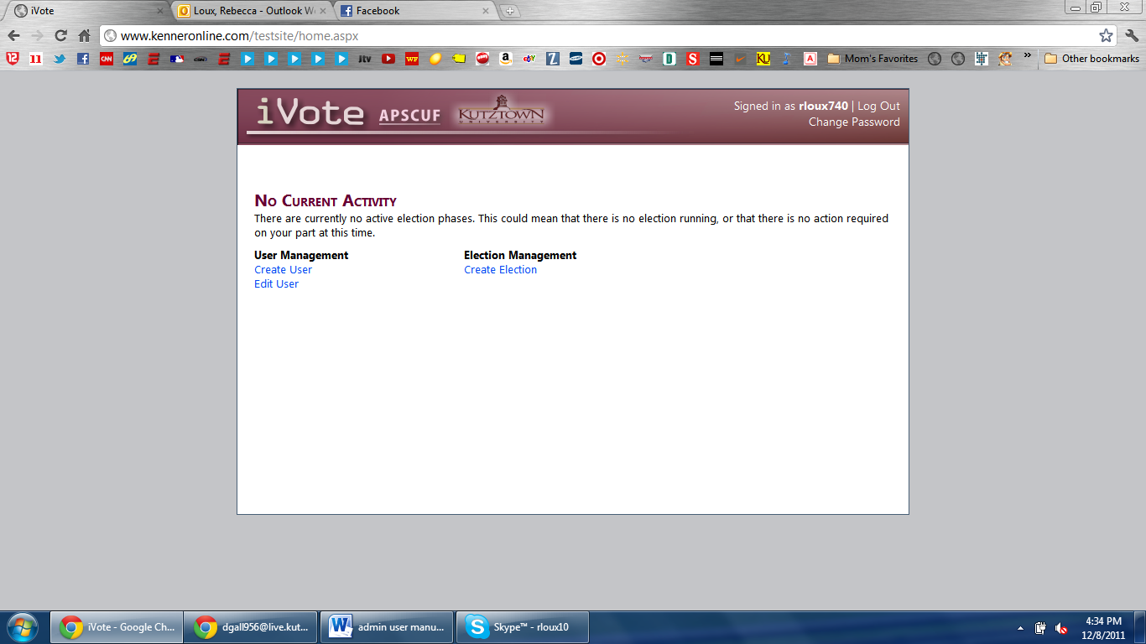On the homepage, click the “Create User” link.
3. Fill out the form and select what kind of account you want the new member to be then click on “Create User”
4. This will then send an email to the new member saying they have been added to the system and there will be a link included in the email to make a password in order to log in to the system.

**EDIT USER**

The administrator will be able to edit any users that have been previously added to the database.

1. The administrator will login.
2. On the homepage, click the link that says “Edit User”. 
3. In the table that is displayed, find the name of the member that you would like to edit.
4. Go to the last column in the table and click “Edit User”.
5. After you are done making the necessary changes, click “Save Changes” and your changes will be updated in the database.

**DELETE USER**

The administrator will be able to delete any user that has previously been added to the database.

1. Follow steps 1 – 4 in the Edit User section of the manual.
2. 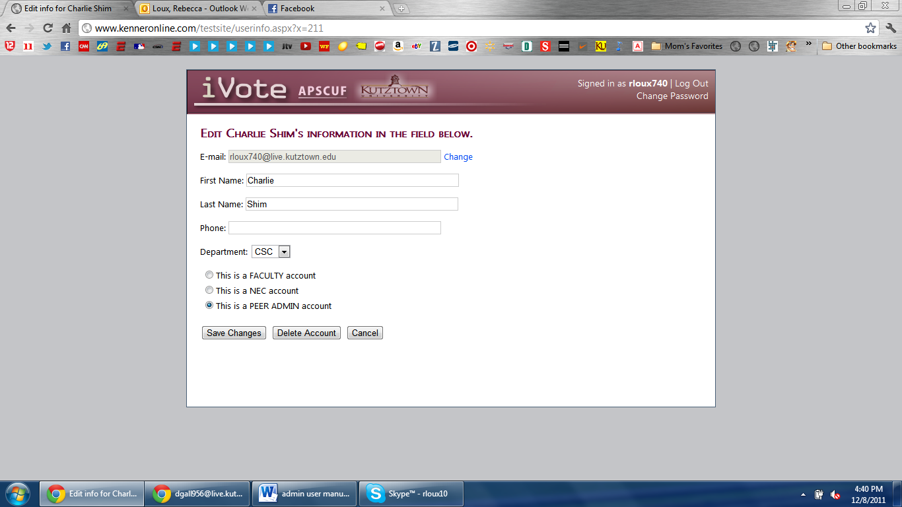Click “Delete Account”.
3. The user account will be deleted from the database.

**CREATE AN ELECTION**

The administrator will be able to create an election.

1. The administrator will login.
2. On the homepage, click the link that says “Create Election”.

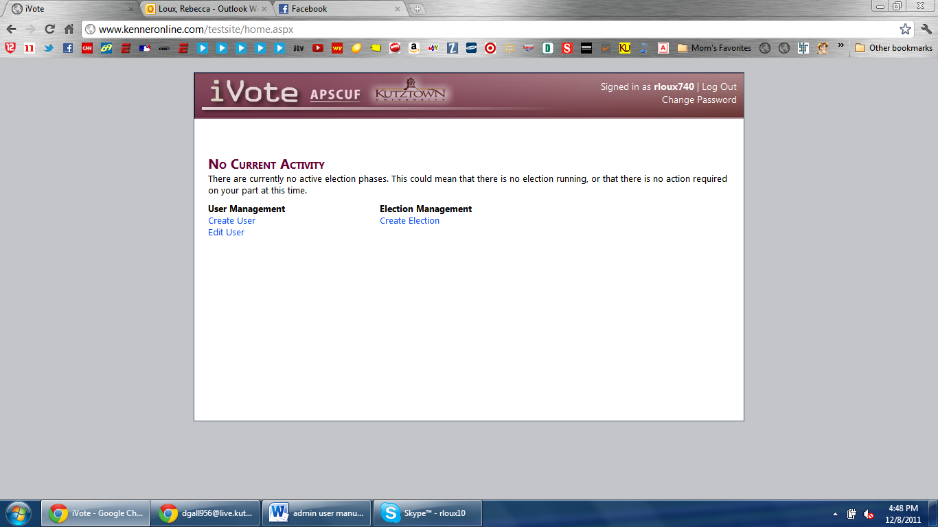

1. 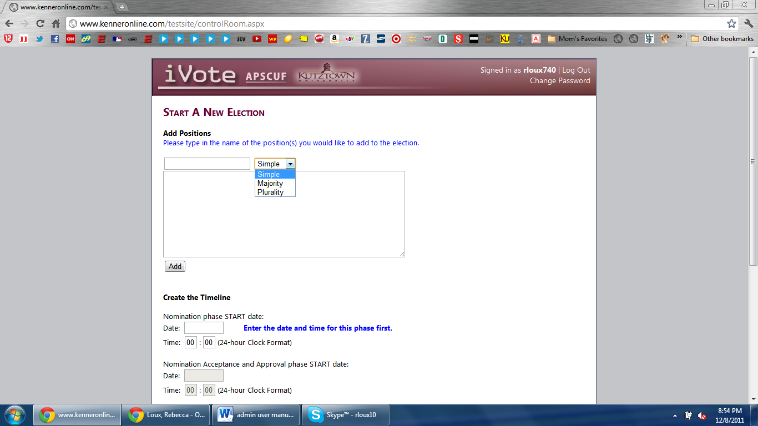At the top, you are able to put in the position(s) that will be in the election and the description of each position, along with what kind of voting tally you will use.
2. Click “Add” when done filling out. This needs to be done after every position (if there are 3 positions, you will click “Add” 3 times.
3. Next, the administrator needs to decide the dates and times that each phase of the election will occur. When entering in a time, make sure it is converted to military time. For example, 12:30 a.m. would be 00:30 and 3:30 p.m. would be 15:30.

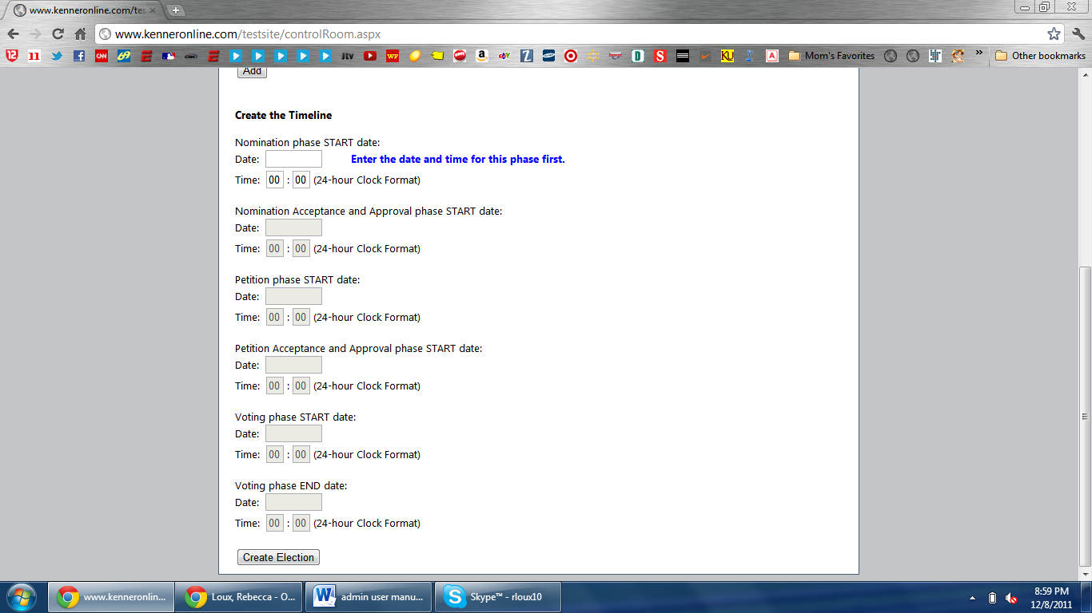

1. After setting up dates and times, click the “Create Election”.
2. You will then be shown a page that displays the times you selected and how long it will be until each phase ends.

***PETITION PHASE***

During the petition phase, the administrator has several functionalities.

**APPROVE ELIGIBILITY**

1. The administrator will login during the petition phase.
2. On the home page, click “Approve Eligibility”.

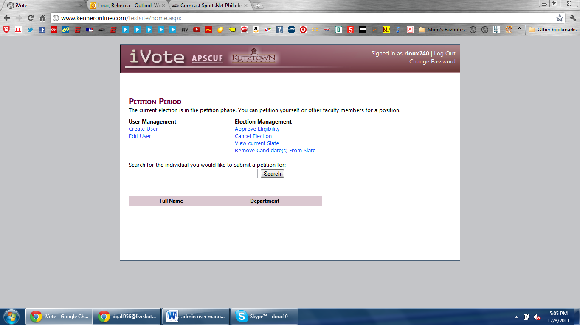

1. 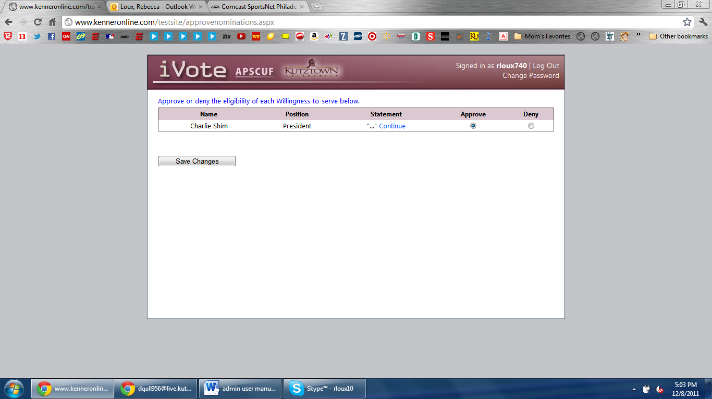You can choose whether to approve or deny a member’s eligibility.
2. Click “Save Changes” when you are finished. These changes will be updated in the database.

**CANCEL ELECTION**

The administrator will have the option to cancel an election at any time for whatever reason.

1. The administrator will login during an election phase.
2. Click “Cancel Election” on the home page.



1. You are able to enter a reason for why you cancelled the election.
2. Click “Cancel Election.

**REVIEW SLATE**

The administrator is able to view the current slate.

1. The administrator will login.
2. ****On home page, click “View Current Slate”.
3. The current slate will be displayed.

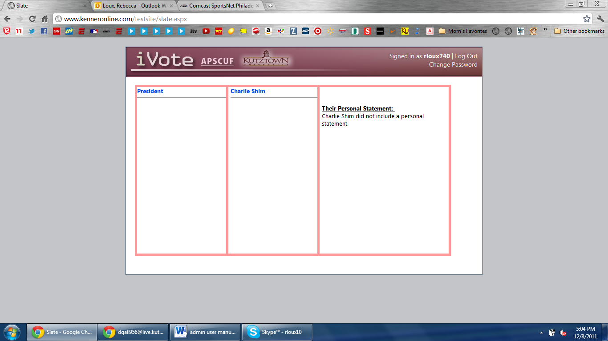

**REMOVE CANDIDATE FROM BALLOT**

The administrator will be able to remove a candidate from the ballot.

1. The administrator will login.
2. ****Click “Remove Candidate(s) from Ballot” on home page.
3. 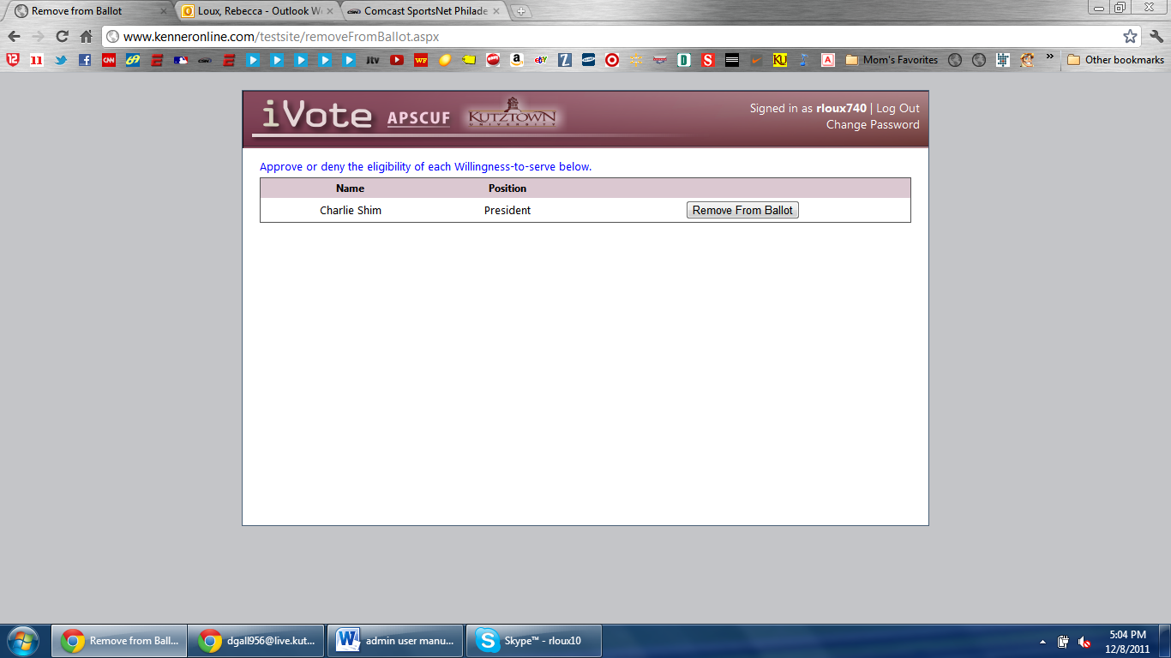Find the member that you would like to remove, click “Remove from Ballot”.
4. Click “OK” in the confirmation box. The candidate will be removed from the ballot.

**PETITION A CANDIDATE**

The administrator will be able to petition a candidate.

1. The administrator will login.
2. On the home page, in the search bar, type any name.

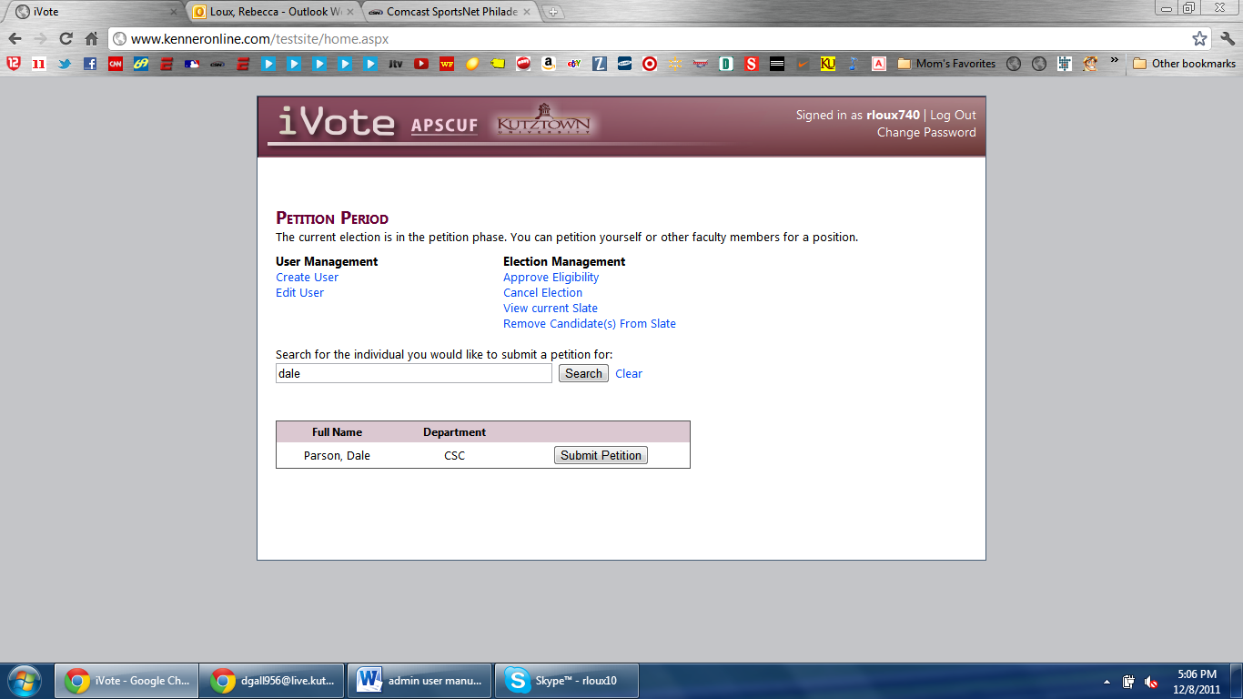

1. Click “Submit Petition” when the person you searched for is displayed.
2. You will need to pick which position you want to petition them for in the drop down list.
3. Click “Submit Petition”.

***VOTING PERIOD***

**VOTE FOR CANDIDATE**

The administrator will be able to vote for each position.

1. The administrator will login.
2. On the homepage, click the position that you want to vote for.
3. Click the candidate that you wish to vote for.
4. 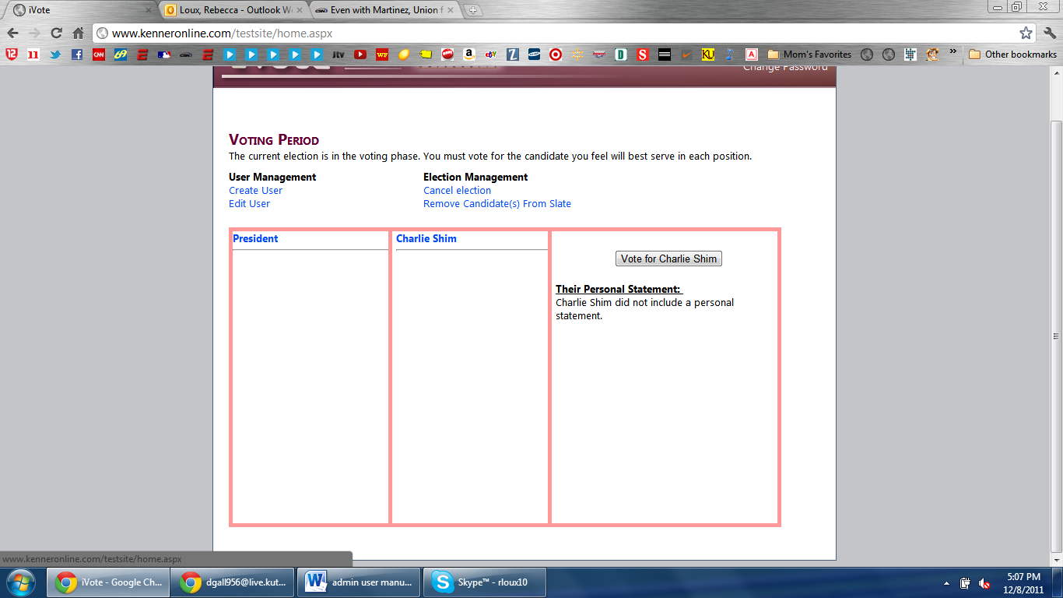Click “Vote for (name)”.
5. After you are done voting, click “Submit Ballot”.

***RESULTS***

The administrator will be able to view the election results and the total vote count for each position.

1. The administrator will login.
2. On the homepage, the results of the election will be displayed.
3. Click “View Position Result Data” to see how many votes there were for each candidate.

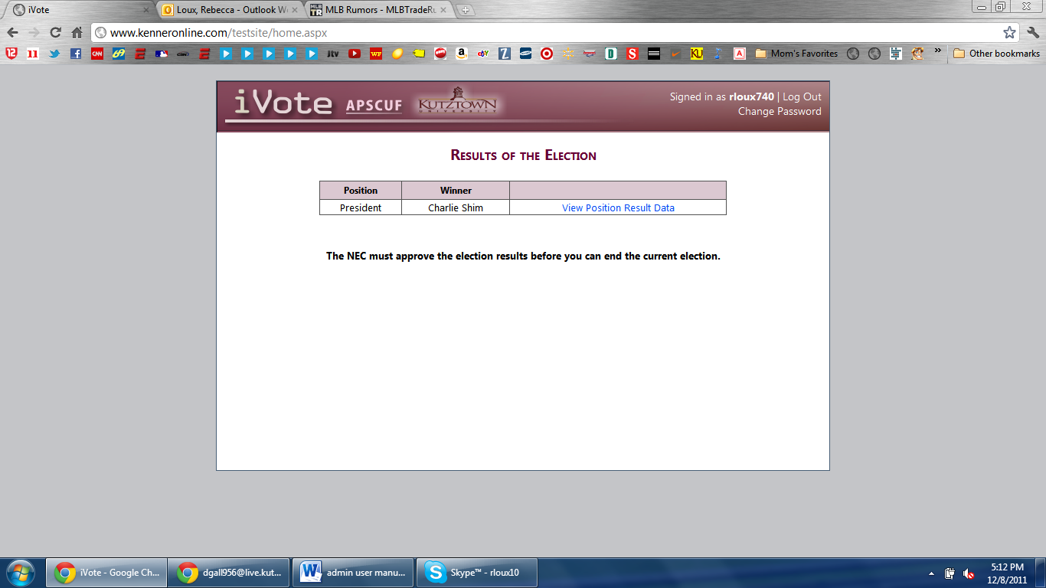

1. 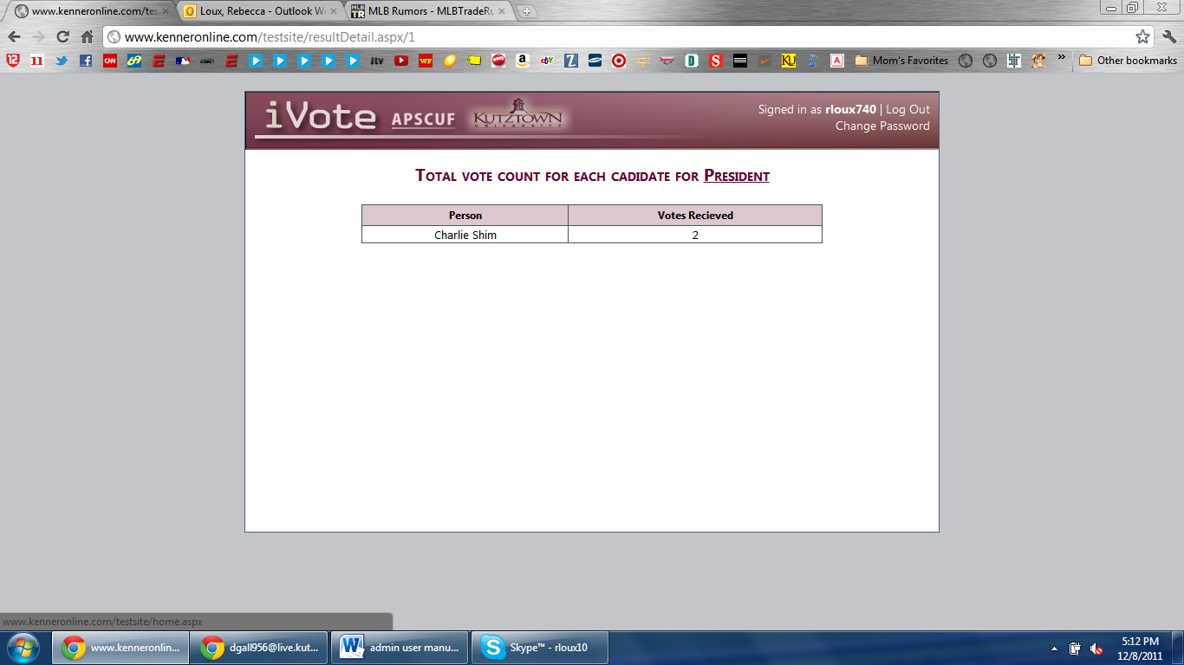The tallies will be displayed.

**ADMINISTRATOR CHANGE PASSWORD**

The administrator will be able to change their password at any time.

1. The administrator will login.
2. Click “Change Password” in the upper right hand corner.

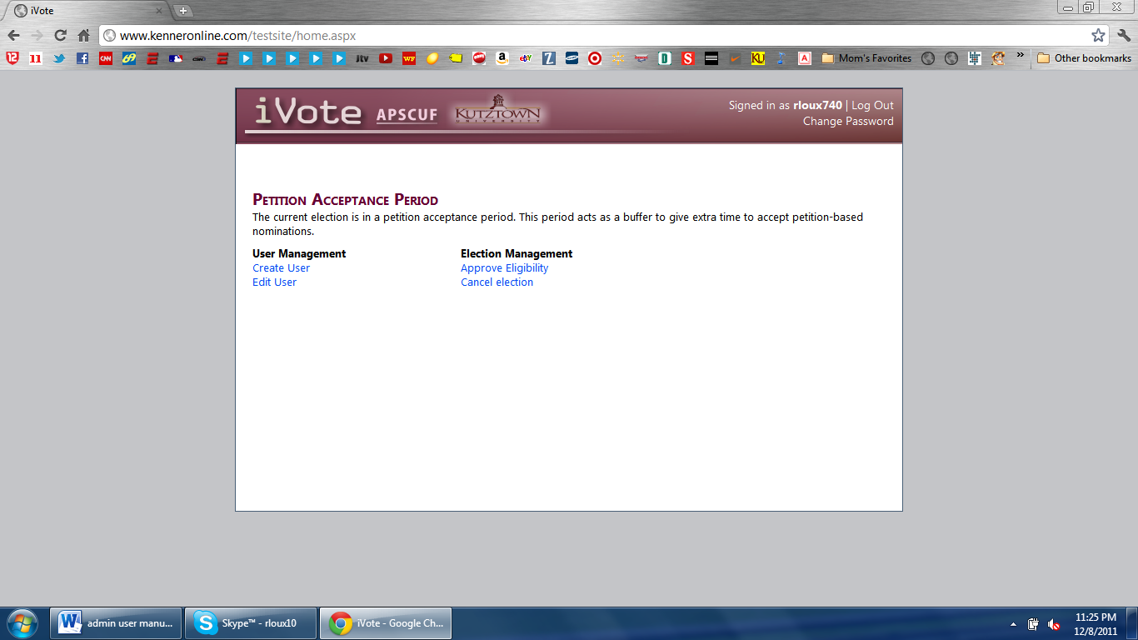

1. Fill in your new password, type it again to confirm it, and type your old password in.
2. Click “Submit”. Your password will be updated in the database.

**ADMINISTRATOR RECOVER PASSWORD**

The administrator will be able to recover their password at any time.

1. On the login page, click “Forgot Password?”

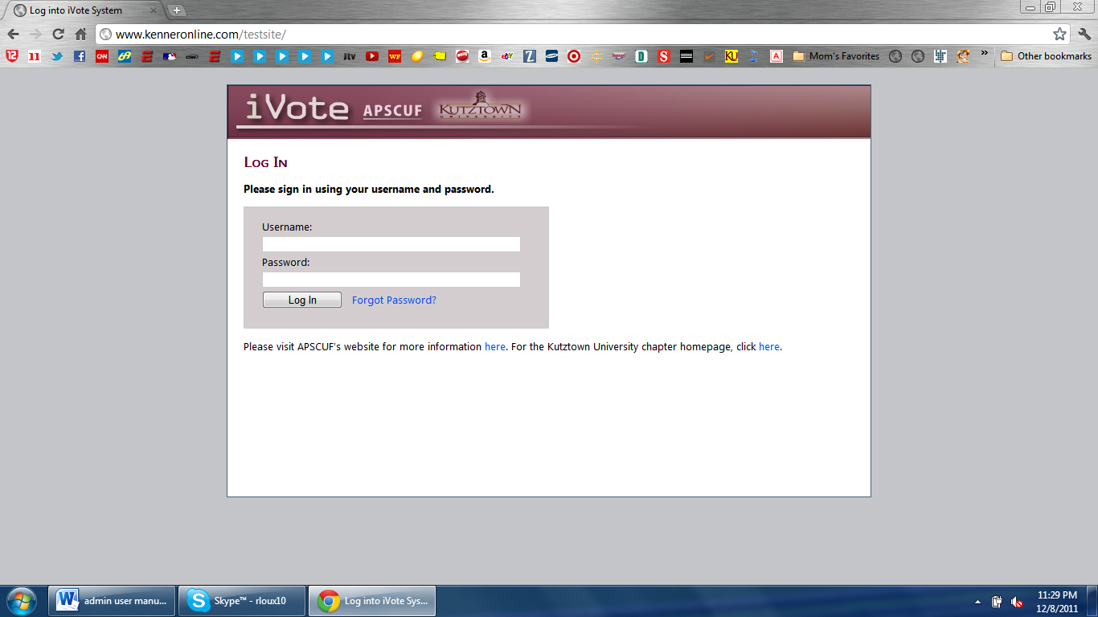

1. Enter your email address and click “Submit”.
2. Check your email account for the link to change your password.

**NEC FUNCTIONS**

**Nominee Slate Approval**

This is a special phase in which an NEC member must log in to approve the nominee slate. If there is a nominee that should not be on the slate, you must contact the administrator to remove that person. Below is a screen capture of the Slate Approval Phase.

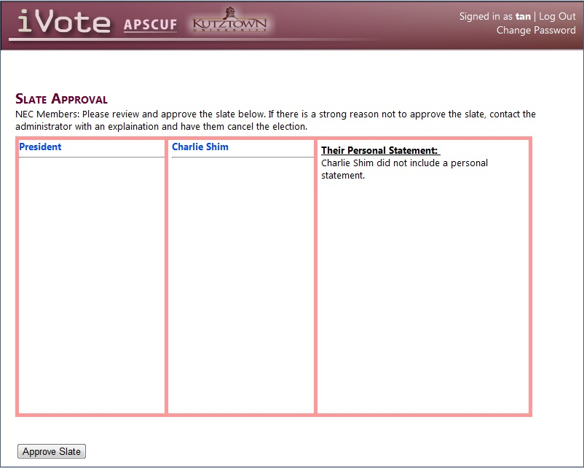

You can view all the nominees by role, and click the "Approve Slate" button at the bottom to allow the election to progress to the petition phase.

**Ballot Results Approval**

An NEC member must log in to approve the ballot results. Below is a screenshot of this phase.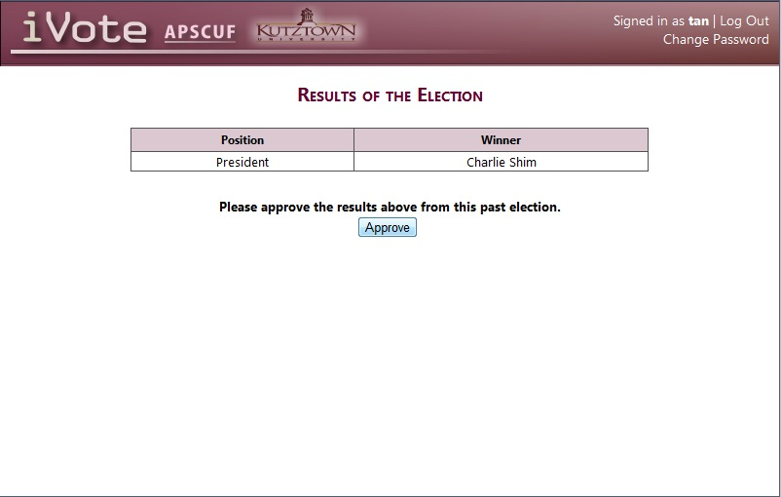

Simply click the approve button and all faculty members will be able to view the election results. These results will be taken down when an administrator chooses to end the election.

**FAQ**

Q: As an admin, can I change a user’s password?

A: No, That is their responsibility. They have the option when they are logged in. If they forget their password there is a link for them to reset it at the login screen.

Q: How does an admin create a user account?

A: Upon logging in, there is a link allowing and admin to do this.

Q: How do the faculty members know to log in and perform actions?

A: The admin must log in at the beginning of each phase to allow the systems to send emails to everyone informing them of this.

Q: Can an election be canceled once started?

A: Yes. The admin has the power to cancel an election.

Q: As an admin, can I edit the details of a faculty member’s information?

A: Yes, as soon as you are logged in, there is a link to do so.

Q: How are the results announced to the faculty?

A: The system will display the results of the election when the users log in.

Q: How can an admin approve the eligibility of faculty members wanting to elect themselves or that have been elected by someone?

A: During the Nominations phase and the Petitions phase, there will be a list of faculty members to approve upon logging in.

Q: Are the admin and NEC members able to remove faculty members from the slate?

A: Yes. When logging in during the Nominations phase, there is an option to do this.

Q: How do I reset my password?

A: When you are logged in there is a link at the top right of the screen.